Systems Architecture and Engineering

(Transforming Enterprise Needs to Requirements)

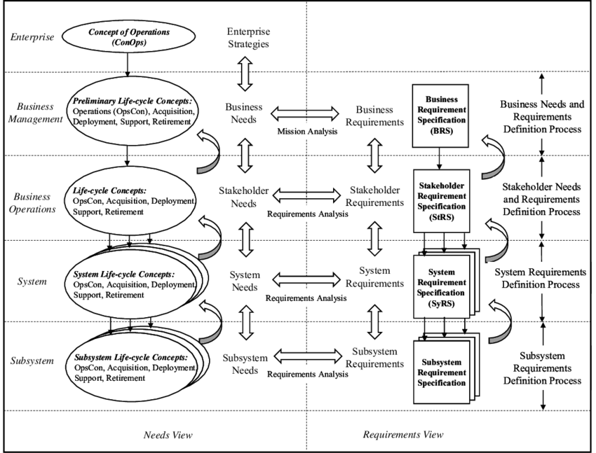

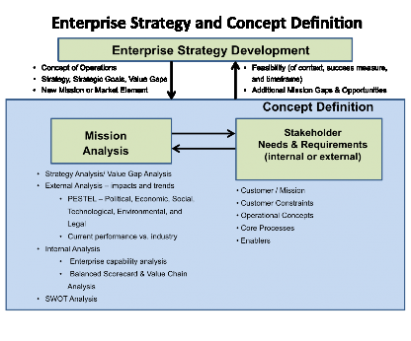

1. Methods and Modeling Techniques

MA uses several techniques, such as

* + use case analysis;
  + operational analysis;
  + functional analysis;
  + technical documentation review;
  + trade studies;
  + modeling;
  + simulation;
  + prototyping;
  + workshops, interviews, and questionnaires;
  + market competitive assessments;
  + benchmarking; and
  + organizational analysis techniques (e.g., strengths, weaknesses, opportunities, threats (SWOT analysis), and

product portfolios).

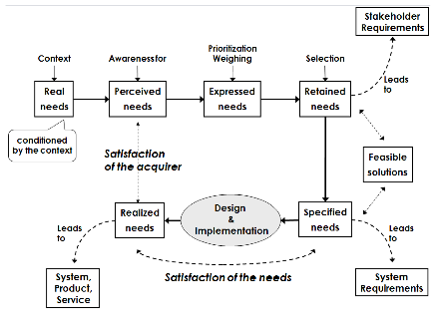

Top-down Development of Architecture and Design, and Requirements (Faisandier 2012). Permission granted by Sinergy'Com. All other rights are reserved by the copyright owner.

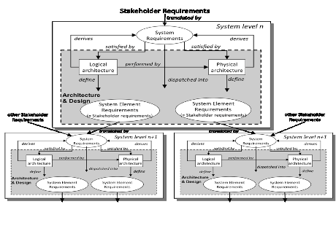

Recursive Instantiation of Definition Processes (Faisandier 2012). Permission granted by Sinergy'Com. All other rights are reserved by the copyright owner.

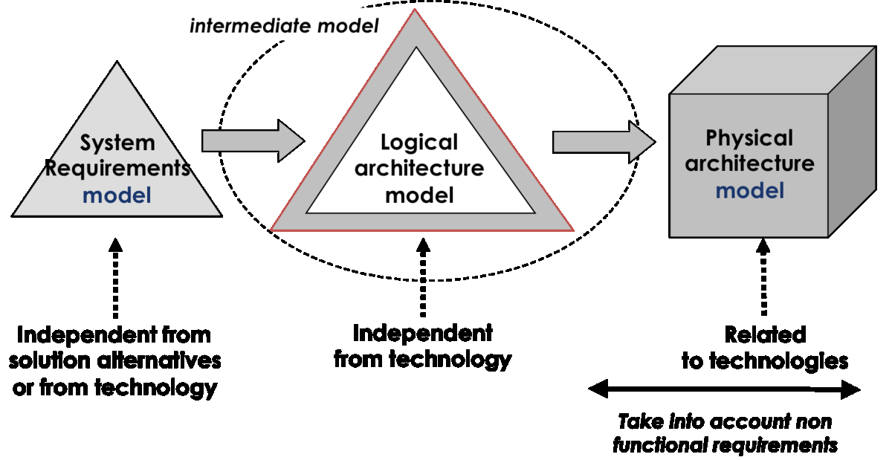

## System Specification

System Specification

|  |  |  |  |  |
| --- | --- | --- | --- | --- |
| Sys spec | Capability:  Move people between Los Angeles and New York  Condition:  Cruising speed of 2500 km/hr  Constraint:  Maximum speed of 5300 km/h | Capability:  Move people between Los Angeles and New York  Condition:  Cruising speed of 200 km/hr  Constraint:  Maximum speed of 300 km/hr | Well-formed requirement:  This system should move people between Los Angeles and New York at an  optimal cruising speed of 200 km/hr with a maximum speed of 300 km/hr. |  |
|  | Table of contents |  |  |  |
|  | List of figures |  |  |  |
|  | List of tables |  |  |  |
|  | 1. Introduction |  |  |  |
|  | **1.1 System purpose** |  |  |  |
|  | **1.2 System scope** |  |  |  |
|  | 1.3 Definitions, acronyms, and abbreviations |  |  |  |
|  | 1.4 References |  |  |  |
|  | 1.5 System overview |  |  |  |
|  | 2. |  |  |  |
|  | General system description |  |  |  |
|  | 2.1 System context |  |  |  |
|  | **2.2 System modes and states** |  |  |  |
|  | **2.3 Major system capabilities** |  |  |  |
|  | **2.4 Major system conditions** |  |  |  |
|  | **2.5 Major system constraints** |  |  |  |
|  | 2.6 User characteristics |  |  |  |
|  | 2.7 Assumptions and dependencies |  |  |  |
|  | **2.8 Operational scenarios** |  |  |  |
|  | 3. |  |  |  |
|  | **System capabilities, conditions, and constraints** |  |  |  |
|  | NOTE—System behavior, exception handling, manufacturability, and deployment should be covered |  |  |  |
|  | under each capability, condition, and constraint. |  |  |  |
|  | 3.1 Physical |  |  |  |
|  | 3.1.1 Construction |  |  |  |
|  | 3.1.2 Durability |  |  |  |
|  | 3.1.3 Adaptability |  |  |  |
|  | 3.1.4 Environmental conditions |  |  |  |
|  | **3.2 System performance characteristics** |  |  |  |
|  | 3.3 System security |  |  |  |
|  | 3.4 Information management |  |  |  |
|  | **3.5 System operations** |  |  |  |
|  | 3.5.1 System human factors |  |  |  |
|  | 3.5.2 System maintainability |  |  |  |
|  | 3.5.3 System reliability |  |  |  |
|  | 3.6 Policy and regulation |  |  |  |
|  | 3.7 System life cycle sustainment |  |  |  |
|  | **4. System interfaces** |  |  |  |

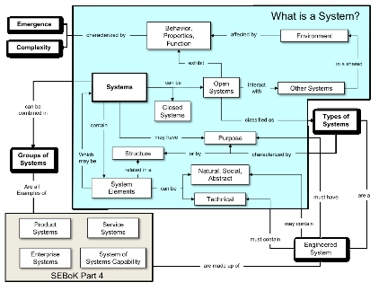

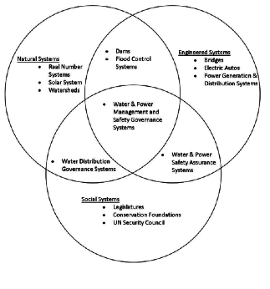

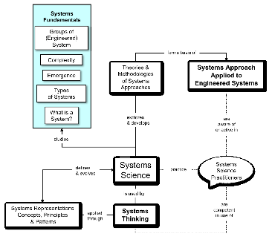

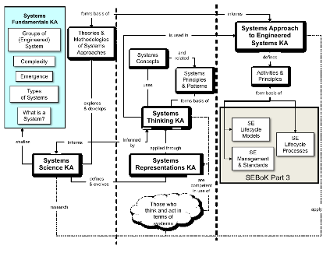

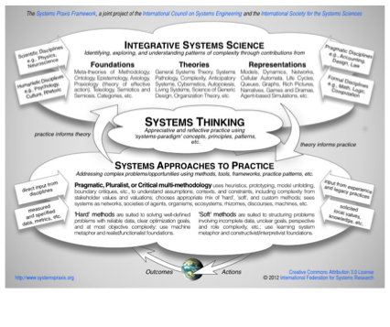

# Use case model

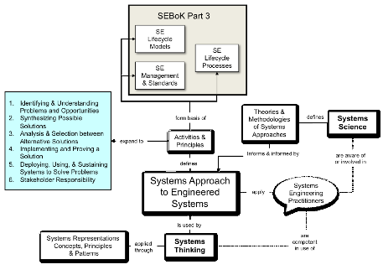

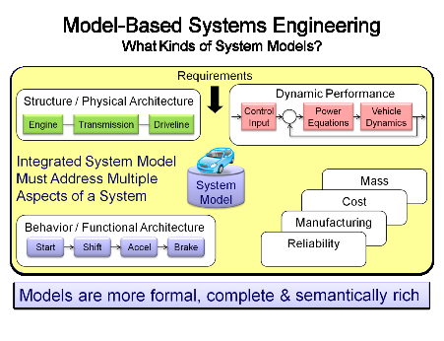

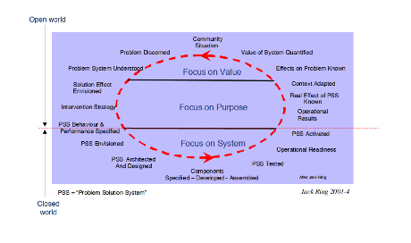

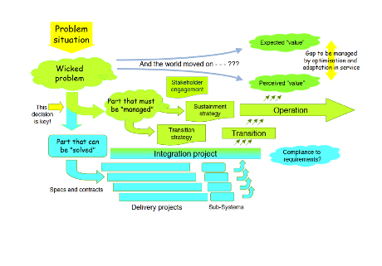

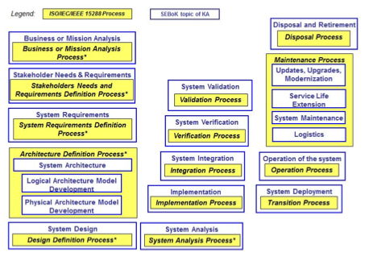

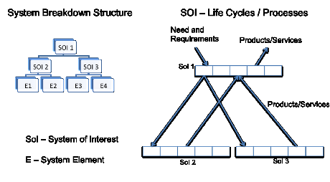

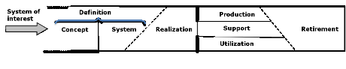

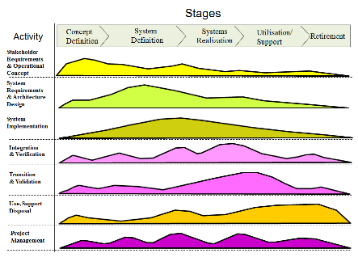

Generic Relationships between life cycle stages and processes (modified from Lawson 2010)

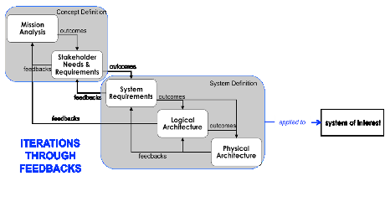

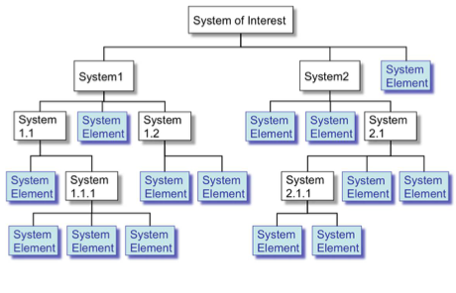

Hierarchical Decomposition of a System-of-Interest (Faisandier 2012). Permission Granted by Sinergy'Com. All other rights are reserved by the copyright owner.

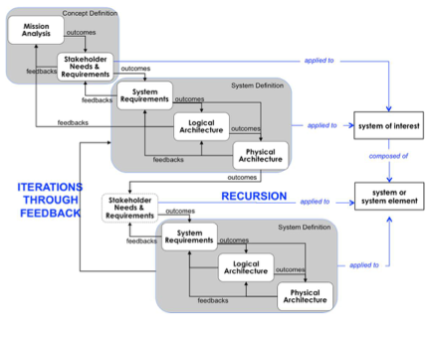

Recursion of Processes on Layers (Faisandier 2012). Permission Granted by Sinergy'Com. All other rights are reserved by the copyright owner.

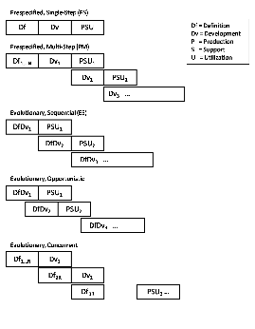

Primary Models of Incremental and Evolutionary Development.

(SEBoK Original)

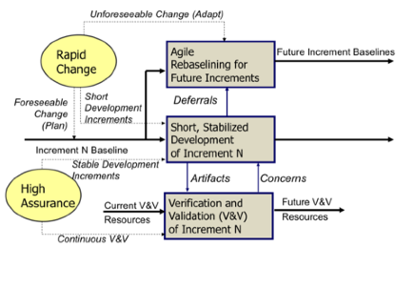

Evolutionary-Concurrent Rapid Change Handling and High Assurance (Pew and Mavor 2007, Figure 2-6). Reprinted with permission from the National Academy of Sciences, Courtesy of National Academies Press, Washington, D.C. All other rights are reserved by the copyright owner.

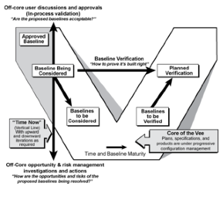

Left Side of the Sequential Vee Model (Forsberg, Mooz, and Cotterman 2005). Reprinted with permission of John Wiley & Sons Inc. All other rights are reserved by the copyright owner.

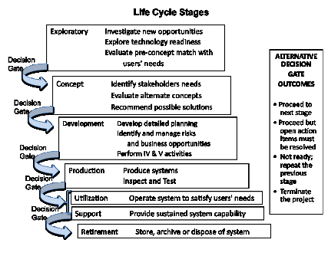

An Example of Stages, Their Purposes and Major Decision Gates. (SEBoK Original)

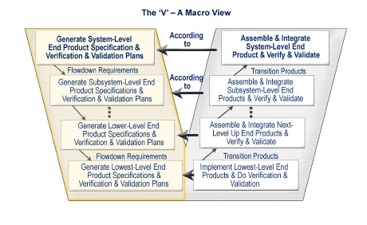

The Vee Activity Diagram (Prosnik 2010). Released by the Defense Acquisition University (DAU)/U.S. Department of Defense (DoD).

Application of the V-model

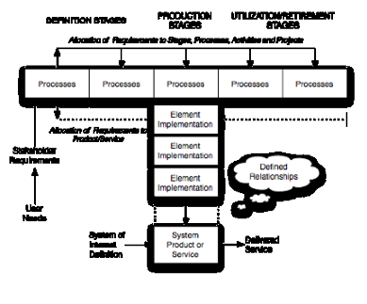

Generic (T) Stage Structure of System Life Cycle Models (Lawson 2010). Reprinted with permission of Harold Lawson. All other rights are reserved by the copyright owner.

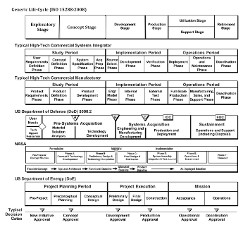

Comparisons of Life Cycle Models (Forsberg, Mooz, and Cotterman 2005). Reprinted with permission of John Wiley & Sons. All other rights are reserved by the copyright owner.

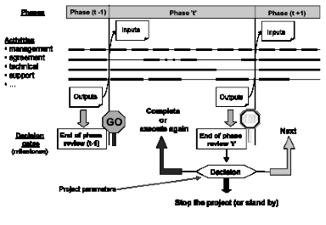

Scheduling the Development Phases. (SEBoK Original)

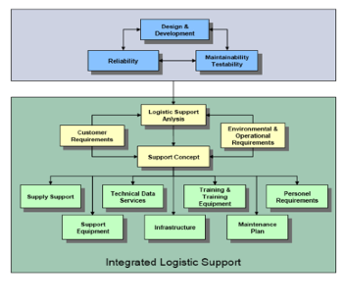

Relating ILS to the System Life Cycle (Eichmueller and Foreman 2009). Reprinted with permission of of ASD/AIA S3000L Steering Committee. All other rights are reserved by the copyright owner.

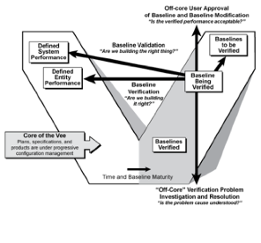

Right Side of the Vee Model (Forsberg, Mooz, and Cotterman 2005). Reprinted with permission of John Wiley & Sons Inc. All other rights are reserved by the copyright owner.

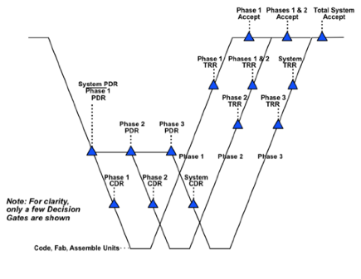

Incremental Development with Multiple Deliveries (Forsberg, Mooz, and Cotterman 2005). Reprinted with permission of John Wiley & Sons Inc. All other rights are reserved by the copyright owner.

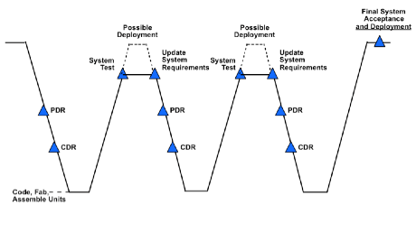

Evolutionary Generic Model (Forsberg, Mooz, Cotterman 2005). Reprinted with permission of John Wiley & Sons, Inc. All other rights are reserved by the copyright owner.

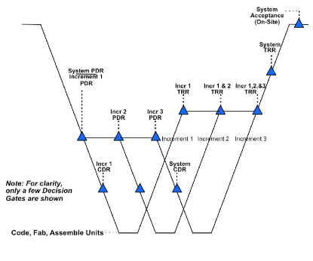

Incremental Development with a Single Delivery (Forsberg, Mooz, Cotterman 2005). Reprinted with permission of John Wiley & Sons Inc. All other rights are reserved by the copyright owner.

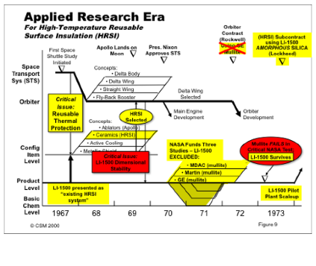

Evolution of Components and Orbiter Subsystems (including space shuttle tiles) During Creation of a Large "Single-Pass" Project (Forsberg 1995). Reprinted with permission of Kevin Forsberg. All other rights are reserved by the copyright owner.

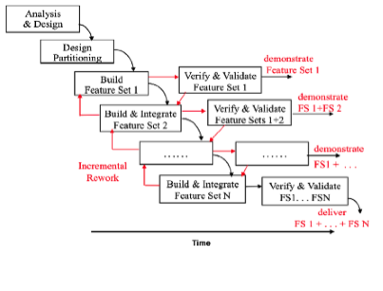

Incremental Build-Verify-Validate-Demonstrate Cycles (Fairley 2009). Reprinted with permission of the IEEE Computer Society and John Wiley & Sons Inc. All other rights are reserved by the copyright owner.

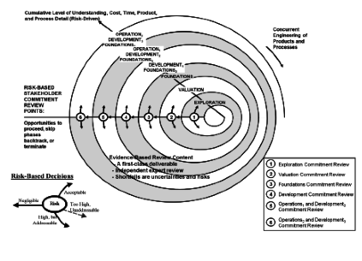

The Incremental Commitment Spiral Model (ICSM) (Pew and Mavor 2007). Reprinted with permission by the National Academy of Sciences, Courtesy of National Academies Press, Washington, D.C. All other rights are reserved by the copyright owner.

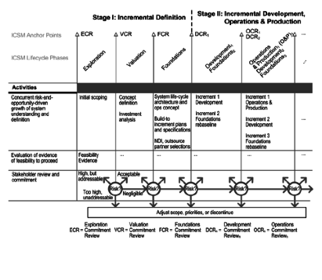

Phased View of the Generic Incremental Commitment Spiral Model Process (Pew and Mavor 2007). Reprinted with permission by the National Academy of Sciences, Courtesy of National Academies Press, Washington, D.C. All other rights are reserved by the copyright owner.

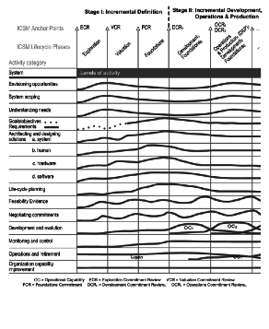

ICSM Activity Categories and Level of Effort (Pew and Mavor 2007).

Reprinted with permission by the National Academy of Sciences, Courtesy of National Academies Press, Washington, D.C. All other rights are reserved by the copyright owner.

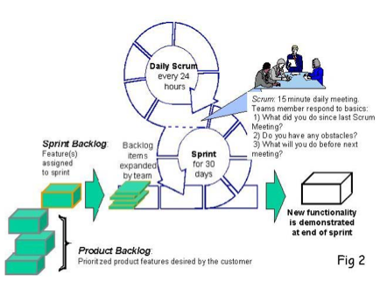

Example Agile Process Flow: Scrum (Boehm and Turner 2004). Reprinted with permission of Ken Schwaber. All other rights are reserved by the copyright owner.

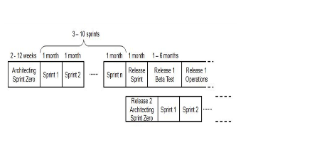

Example of Architected Agile Process (Boehm 2009). Reprinted with permission of Barry Boehm on behalf of USC-CSSE. All other rights are reserved by the copyright owner.

Agile Practices and Principles

Lean Systems Engineering and Development

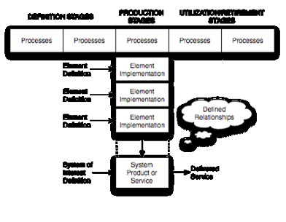

Generic (T) Stage Structure of System Life Cycle (Lawson 2010). Reprinted with permission of Harold "Bud" Lawson. All other rights are reserved by the copyright owner.

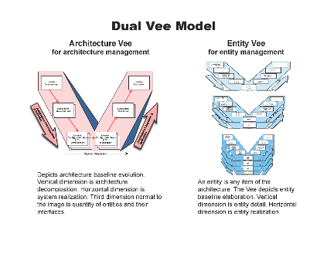

The Dual Vee Model (2a) (Forsberg, Mooz, Cotterman 2005). Reprinted with permission of John Wiley & Sons Inc. All other rights are reserved by the copyright owner.

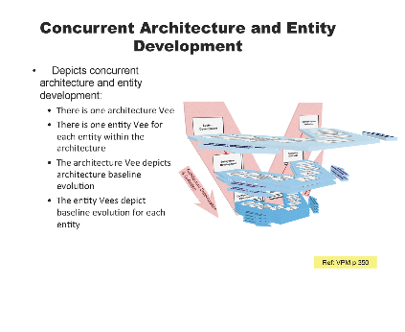



Figure 2b. The Dual Vee Model (2b) (Forsberg, Mooz, Cotterman 2005). Reprinted with permission of John Wiley & Sons Inc. All other rights are reserved by the copyright owner.

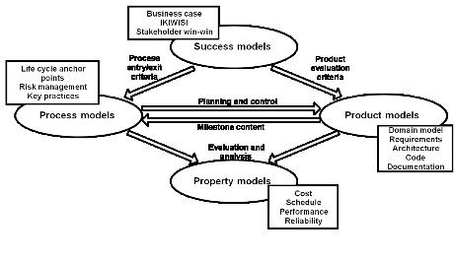

Spiral Model Support for Process Models, Product Models, Success Models, Property Models (Boehm and Port 1999). Reprinted with permission of © Copyright IEEE – All rights reserved. All other rights are reserved by the copyright owner.

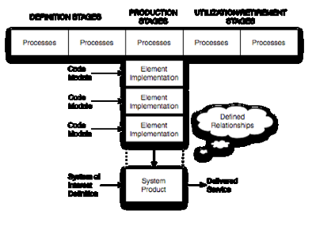

T-Model for Software System (Lawson 2010). Reprinted with permission of Harold "Bud" Lawson. All other rights are reserved by the copyright owner.

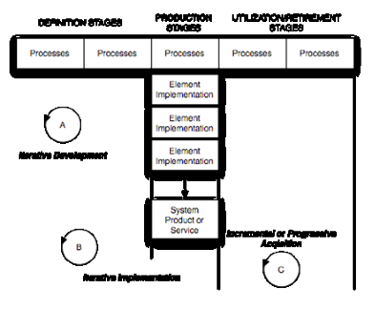

Iteration Through Life Cycle Stages (Lawson 2010). Reprinted with permission of Harold "Bud" Lawson. All other rights are reserved by the copyright owner.

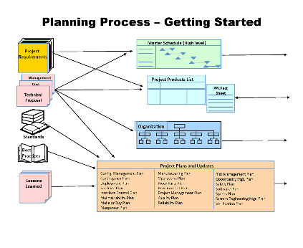

New Product Planning Process – Getting Started (Forsberg, Mooz, and Cotterman 2005). Reprinted with permission of John Wiley & Sons Inc. All other rights are reserved by the copyright owner.

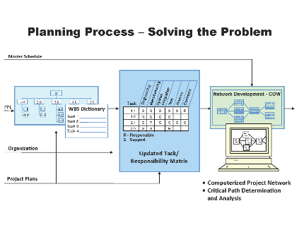

New Product Planning Process Solving the Problem (Forsberg, Mooz, and Cotterman 2005). Reprinted with permission of John Wiley & Sons Inc. All other rights are reserved by the copyright owner.

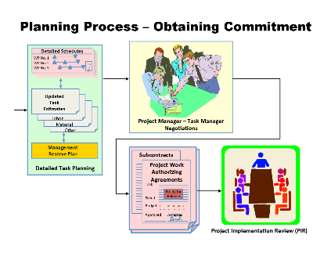

New Product Planning Process – Getting Commitment (Forsberg, Mooz, and Cotterman 2005). Reprinted with permission of John Wiley & Sons Inc. All other rights are reserved by the copyright own

Types of Systems

* **product system (glossary) /software or system**
* **service system (glossary) /software or system**
* **enterprise system (glossary)**
* **system of systems (SoS) capability**

Part 3: SE and Management

Systems Engineering and Management 1

Introduction to Life Cycle Processes 5

Generic Life Cycle Model 8

Applying Life Cycle Processes 11 L

ife Cycle Processes and Enterprise Need 18

Life Cycle Models 22

System Life Cycle Process Drivers and Choices 27

System Life Cycle Process Models: Vee 33

System Life Cycle Process Models: Iterative 45

Integration of Process and Product Models 64

Lean Engineering 75

Concept Definition 78

Business or Mission Analysis 81

Stakeholder Needs and Requirements 88

System Definition 95

System Requirements 101

System Architecture 111

Logical Architecture Model Development 120

Physical Architecture Model Development 129

System Design 137

System Analysis 142

System Realization 149

System Implementation 154

System Integration 159

System Verification 169

System Validation 177

System Deployment and Use 188

System Deployment 190

Operation of the System 194

System Maintenance 197

Logistics 200

# Quality attribute scenarios

# Constraints

# Architectural concerns

# Existing architecture documentation

# Model-based systems engineering